**PROBLEM SOLVING**

(Solving various problems using C language)

*Summer Internship Report Submitted in partial fulfilment*

*of the requirement for under graduate degree of*

**Bachelor of Technology**

In

**Computer Science Engineering**

By

**Chavan Aniketh**

**221710311009**

<https://github.com/Aniketh821/>

*Under the Guidance of*



Department Of Computer Science & Engineering

GITAM School of Technology

GITAM (Deemed to be University)

Hyderabad-502329

June 2019

**DECLARATION**

I submit this industrial training work entitled “**Solving various problems using C** **language**” to GITAM (Deemed to Be University), Hyderabad in partial fulfilment of the requirements for the award of the degree of “**Bachelor of** **Technology**” in “**Computer Science & Engineering**”. I declare that it was carried out independently by me under the guidance of Asst. Professor, GITAM (Deemed to Be University), Hyderabad, India.

The results embodied in this report have not been submitted to any other University or Institute for the award of any degree or diploma.

Place: HYDERABAD CHAVAN ANIKETH.

Date: 20-07-20 221710311009



GITAM (DEEMED BE TO UNIVERSITY)

     Hyderabad-502329, India

                                                                 Dated: 20-7-2020

**CERTIFICATE**

This is to certify that the Industrial Training Report entitled as **“Solving Various Problems Using C Language and Python”** is being submitted by CHAVAN ANIKETH (221710311009) in partial fulfilment of the requirement for the award of **Bachelor of Technology** **in Computer Science Engineering** at GITAM (Deemed To Be University), Hyderabad during the academic year 2019-20.

It is faithful record work carried out by her at the **Computer Science Engineering Department**, GITAM University Hyderabad Campus under my guidance and supervision.

**Dr. S. Phani Kumar**

Assistant Professor                                                              Assistant Professor and HOD

Department of CSE                                                         Department of CSE

**ACKNOWLEDGEMENT**

Apart from my effort, the success of this internship largely depends on the encouragement and guidance of many others. I take this opportunity to express my gratitude to the people who have helped me in the successful competition of this internship.

I would like to thank respected **Dr. N. Siva Prasad,** Pro Vice Chancellor, GITAM Hyderabad and **N. Seetharamaiah,** Principal, GITAM Hyderabad

I would like to thank respected **Mr. S Phani Kumar,** Head of the Department of Computer Science and Engineering for giving me such a wonderful opportunity to expand my knowledge for my own branch and giving me guidelines to present a internship report. It helped me a lot to realize of what we study for.

I would like to thank the respected facultieswho helped me to make this internship a successful accomplishment.

I would also like to thank my friends who helped me to make my work more organized and well-stacked till the end.

                                                                                               CHAVAN ANIKETH

221710311009

**Table of Contents**

**1. Introduction to the project 1**

**2 Problem 1-** Kth Largest factor of N **2**

2.1 Problem statement 2

2.2 Coding 3

2.3 Output 3

**3. Problem 2-** Counting Rock samples **4**

3.1 Problem statement 4

3.2 Coding 5

3.3 Output 6

**4 Problem 3 -** Maneuvering a Cave Problem **7**

4.1 Problem statement 7

4.2 Coding 8

4.3 Output 8

**5 Problem 4 -** Square Free Numbers Problem **9**

5.1 Problem statement 9

5.2 Coding 10

5.3 Output 10

**6 Problem 5 -** Houses Problem **11**

6.1 Problem statement 11

6.2 Coding 12

6.3 Output 12

**7 Problem 6 -** Consecutive Prime Sum **13**

7.1 Problem statement 13

7.2 Coding 14

7.3 Output 14

[**8 Software Requirements**](https://docs.google.com/document/d/1tjcjW_gBxLXJJ8lcM_zoOmIZgnojR5jVKL0I-zXZKt8/edit#heading=h.ihv636) 15

[8.1 Hardware Requirements](https://docs.google.com/document/d/1tjcjW_gBxLXJJ8lcM_zoOmIZgnojR5jVKL0I-zXZKt8/edit#heading=h.32hioqz)  15 8.2[Software Requirements](https://docs.google.com/document/d/1tjcjW_gBxLXJJ8lcM_zoOmIZgnojR5jVKL0I-zXZKt8/edit#heading=h.1hmsyys) 15

**10. Bibliography 16**

**1. Introduction**

Problem Solving is the Process of Designing and carrying out certain steps to reach a Solution. These six problems which are listed below are of different complexity and require different approach and logics in order to achieve desired Output/Solution.

**1. Kth Largest factor of N:** In this problem we will be considering a positive integer N for which we are going to find the factors. After that we are going to find the Kth largest factor of N.

**2. Counting Rock samples:** In this problem we are going to consider N rock samples and range of the samples. From this we need to find how many samples are present in that particular range.

**3. Maneuvering a Cave Problem:** In this problem we are going to consider a matrix mxn from which we will be counting all the possible paths from top left to bottom right of the matrix.

**4. Square Free Numbers Problem:** In this problem we are going to find number of square free numbers that divide a given number. A square free number is one that is not divisible by perfect squares.

**5. Houses Problem:** In this problem, we consider that there are n houses build in a line and each house has some value to it. We are going to find the maximal of these houses value.

**6. Consecutive Prime sum**: In this problem we have find whether the sum of two consecutive prime numbers is prime or not.

I have executed projects in C language. For C, I have used Dev C++.

1

**2. Problem 1**

**Kth Largest factor of N**

In this problem we will be considering a positive integer N for which we are going to find the factors. After that we are going to find the Kth largest factor of N.

**2.1** Problem Statement

A positive integer d is said to be a factor of another positive integer N if when N is divided by d, the remainder obtained is zero. For example, for number 12, there are 6 factors 1, 2, 3, 4, 6, 12. Every positive integer k has at least two factors, 1 and the number k itself. Given two positive integers N and k, write a program to print the kth largest factor of N.

**Input Format:**The input is a comma-separated list of positive integer pairs (N, k).

**Output Format:**The kth highest factor of N. If N does not have k factors, the output should be 1

**Example 1**

* **Input**: 12,3
* **Output**: 4

**Explanation:**N is 12, k is 3. The factors of 12 are (1,2,3,4,6,12). The highest factor is 12 and the third largest factor is 4. The output must be 4.

**Concepts Used To Solve:-**

**Conditional statements:** If and else block is used.

**Loops:** It executes a block of statements number of times until the condition becomes false.

2

**2.2 coding**

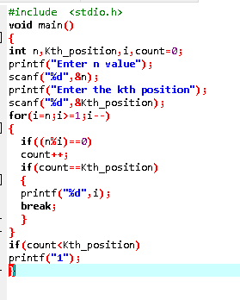 **Fig 2.2.1**

**2.3 Output**

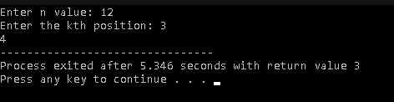

**Fig 2.3.1**

3

**3. Problem 2**

**Counting Rock samples**

In this problem we are going to consider N rock samples and range of the samples. From this we need to find how many samples are present in that particular range.

**3.1 Problem Statement**

Juan Marquinho is a geologist and he needs to count rock samples in order to send it to a chemical laboratory. He has a problem: The laboratory only accepts rock samples by a range of its size in ppm (parts per million).

Juan Marquinho receives the rock samples one by one and he classifies the rock samples according to the range of the laboratory. This process is very hard because the number of rock samples may be in millions.

Juan Marquinho needs your help, your task is to develop a program to get the number of rocks in each of the ranges accepted by the laboratory.

**Input Format :**An positive integer S (the number of rock samples) separated by a blank space, and a positive integer R (the number of ranges of the laboratory); A list of the sizes of S samples (in ppm) as positive integers separated by space R lines where the ith line containing two positive integers, space separated, indicating the minimum size and maximum size respectively of the ith range.

**Output Format:**R lines where the ith line contains a single non-negative integer indicating the number of the samples which lie in the ith range.

**Example**

* Input: 10 2
* 345 604 321 433 704 470 808 718 517 811
* 300 350
* 400 700

**Output**: 2 4

**Explanation:**

There are 10 samples (S) and 2 ranges ( R ). The samples are 345, 604,811. The ranges are 300-350 and 400-700. There are 2 samples in the first range (345 and 321) and 4 samples in the second range (604, 433, 470, 517). Hence the two lines of the output are 2 and 4.

**Concepts used:**

**Array:** An **a**rray is used to store a collection of data, but it is often more useful to think of an array as a collection of variables of the same type.

4

**Loops**: Here I used for loop for iterating the given condition.

**Conditional statements**: If and else if statements.

**3.2 Coding**

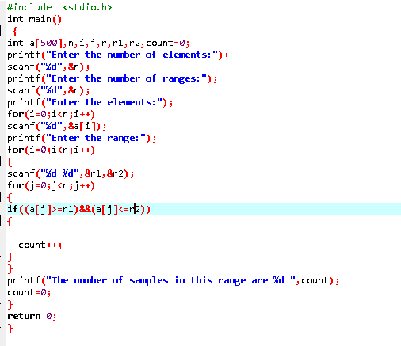

**Fig 3.2.1**

5

3.3 Output:

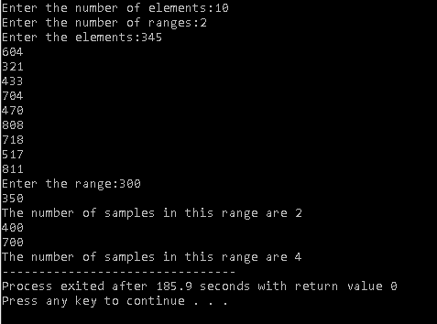

**Fig 3.3 .1**

6

**4. Problem 3**

**Maneuvering a Cave Problem**

In this problem we are going to consider a matrix mxn from which we will be counting all the possible paths from top left to bottom right of the matrix.

**4.1 Problem Statement:-**

The task is to count all the possible paths from top left to bottom right of a m x n matrix with the constraints that from each cell you can either move only to right or down.

**Input:**

* First line consists of T test cases. First line of every test case consists of N and M, denoting the number of rows and number of columns respectively.

**Output:**

* Single line output i.e count of all the possible paths from top left to bottom right of a m x n matrix..

Sample Input Sample output

1. 3,3 6
2. 2,3 3

**Concepts used:**

**Function:** The function contains the set of programming statements enclosed by {}

**Conditional statements:** If and else block is used.

7

**4.2 Coding**

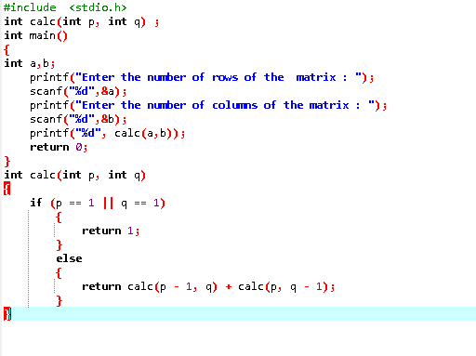

**Fig 4.2.1**

**4.3 Output**

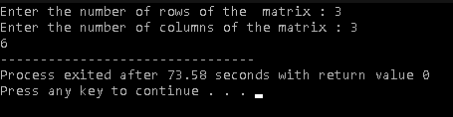

**Fig 4.3.1**

8

**5. Problem 4**

**Square Free Numbers Problem**

In this problem we are going to find number of square free numbers that divide a given number. A square free number is one that is not divisible by perfect squares.

**5.1 problem Statement**

In the theory of numbers, square free numbers have a special place.  A square free number is one that is not divisible by a perfect square (other than 1).  Thus 72 is divisible by 36 (a perfect square), and is not a square free number, but 70 has factors 1, 2, 5, 7, 10, 14, 35 and 70.  As none of these are perfect squares (other than 1), 70 is a square free number.

For some algorithms, it is important to find out the square free numbers that divide a number.  Note that 1 is not considered a square free number.

In this problem, you are asked to write a program to find the number of square free numbers that divide a given number.

**Example 1**

* **Input:-**20
* **Output:-**3

**Explanation**

* N=20
* If we list the numbers that divide 20, they are
* 1, 2, 4, 5, 10, 20
* One (1) is not a square free number, 4 is a perfect square, and 20 is divisible by 4, a perfect square.  2 and 5, being prime, are square free, and 10 is divisible by 1,2,5 and 10, none of which are perfect squares.  Hence the square free numbers that divide 20 are 2, 5, 10. Hence the result is 3.

**Concepts used:**

**Conditional statements:** If and else block is used.

**Loops:** It executes a block of statements number of times until the condition becomes false.

9

**5.2 Coding**

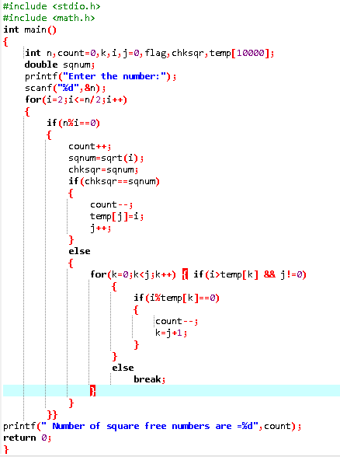

**Fig 5.2.1**

**5.3 Output**

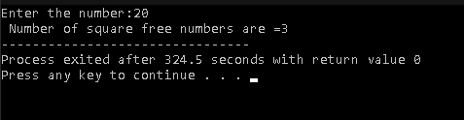

**Fig 5.3.1**

10

**6. Problem 5**

**Houses Problem**

In this problem, we consider that there are n houses build in a line and each house has some value to it. We are going to find the maximal of these houses value.

**6.1 Problem Statement**

There are n houses build in a line, each of which contains some value in it.

A thief is going to steal the maximal value of these houses, but he can’t steal in two adjacent houses because the owner of the stolen houses will tell his two neighbours left and right side.

**Sample Input:** val[] = {6, 7, 1, 3, 8, 2, 5}

**Sample Output:** 20

**Concepts used:**

**Array:** An **a**rray is used to store a collection of data, but it is often more useful to think of an array as a collection of variables of the same type.

**Loops**: Here I used for loop for iterating the given condition.

**Conditional statements**: If and else if statements.

11

**6.2Coding**

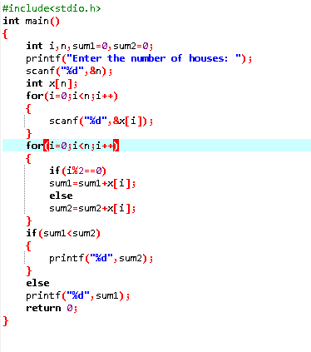

**Fig 6.2.1**

**6.3 Output**

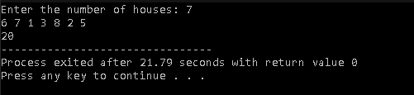

**Fig 6.3.1**

12

**7. Problem 6**

**Consecutive Prime Sum**

**7.1 Problem Statement**

Some prime numbers can be expressed as a sum of other consecutive prime numbers.

**For example**

* 5 = 2 + 3,
* 17 = 2 + 3 + 5 + 7,
* 41=2+3+5+7+11+13.

Your task is to find out how many prime numbers which satisfy this property are present in the range 3 to N subject to a constraint that summation should always start with number 2.

Write code to find out the number of prime numbers that satisfy the above-mentioned property in a given range.

**Input Format:** First line contains a number N

**Output Format:** Print the total number of all such prime numbers which are less than or equal to N.

**Sample Input and Output**

|  |  |  |  |
| --- | --- | --- | --- |
| **SNo.** | **Input** | **Output** | **Comment** |
| 1 | 20 | 2 | (Below 20, there are 2 such numbers: 5 and 17). 5=2+3 17=2+3+5+7 |
| 2 | 15 | 1 |  |
|  |  |  |  |

**Concepts used:**

**Function:** The function contains the set of programming statements enclosed by {}

**Conditional statements:** If and else block is used.

**Loops:** It executes a block of statements number of times until the condition becomes false.

13

**7.2 Coding**

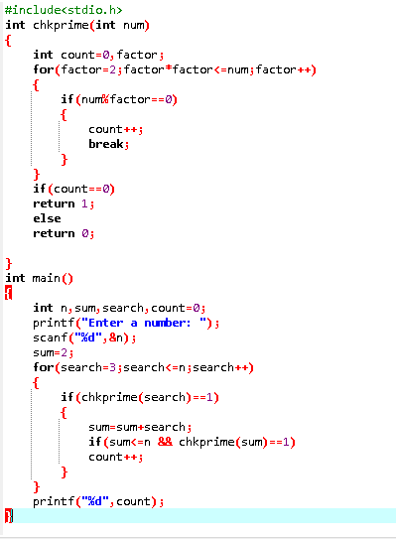

**Fig 7.2.1**

**7.3 Output**

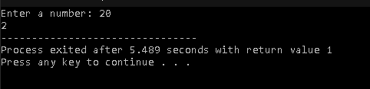

**Fig 7.3.1**

14

**8. Software requirements:**

**8.1 Hardware requirements**:

This project can be executed in any system or an android phone without prior to any platform. We can use any online compiler and interpreter.

**8.2 Software requirements**

There are two ways to execute this project

1) Online compilers.

2) Software for execution ( Dev c++, etc.)

Online compilers require internet connection. We have many free compilers with which we can code.

Software for execution need to be installed on the user’s system specification. These help us to completely execute the project. These software are based on the platforms.

15

**9. BIBLIOGRAPHY**

* <https://virtualcodeworld.blogspot.com/2020/07/The%20kth%20largest%20factor%20of%20N%20%20Tcs%20CodeVita%20question.html>
* <https://prepinsta.com/tcs-codevita/python-code-for-counting-rock-samples-problem/>
* <https://prepinsta.com/tcs-codevita/python-program-for-maneuvering-a-cave/#:~:text=Maneuvering%20a%20Cave%20Problem%20is,data%20structures%20and%20dynamic%20programming.>
* <https://www.geeksforgeeks.org/square-free-number/>
* <https://www.geeksforgeeks.org/find-maximum-possible-stolen-value-houses/>
* <https://prepinsta.com/tcs-codevita/c-code-for-consecutive-prime-sum/>

16